|  |  |
| --- | --- |
|  | CNG-495 Capstone Project Stage 3: Final Report of E-Commerce Application with ML Capabilities |
|  |  |
|  | Cem KARASU 2315398  Metehan YILMAZ 2315638  11/16/23 |

**1**

Table of Contents

Project Topic 3

Project Description 3

Cloud Delivery Models 3

Architectural Overview 3

User Authentication: 3

Static and Dynamic Content Delivery: 3

Microservices: 4

Workflows: 4

Image Recognition Workflow: 4

Data Storage and Processing: 4

Search MicroService: 4

Diagrams/Figures 5

Expected Contribution 6

Front-End Flutter Mobile Application Development: 6

Report Writing: 6

Cloud Computing Tasks: 6

References 6

Milestones Achieved: 7

Milestones Remained: 8

List of Futures to be delivered: 8

Project Topic 9

Project Description 9

# Project Topic

Developing a Flutter-based e-commerce application on the AWS cloud infrastructure with integrated machine learning capabilities.

# Project Description

This project aims to create an e-commerce application where users can conveniently list their products by adding new items. AWS Cognito manages the authentications of each user and customer. Customers can search and add products to their cart. Payment microservice is not included in this project.

This application solves the problem which is faced during listing. It can be listed wrongly categorized due to human error. Our application eliminates this problem by automatically choosing the category for the product based on its image.

To achieve this, the application utilizes image recognition technology from Amazon Rekognition. When users upload an image to add a new item, Amazon Rekognition automatically identifies the object and selects the category for the product. This functionality streamlines the process of filling in item details by automatically populating certain fields based on previously configured specifications of the identified object.

# Cloud Delivery Models

In our project, we plan to adopt serverless computing as a fundamental part of our architecture. We aim to leverage AWS Lambda for its remarkable ability to automatically scale and handle event-driven tasks. Our focus will be on the simplicity and scalability provided by Lambda and AWS Cognito for serverless user management. We will provide software developed in flutter.

* **SaaS (Software as a Service):** We will provide an e-commerce application that users can list products.

# Architectural Overview

## User Authentication:

AWS Cognito for serverless user management, ensuring secure and scalable authentication.

## Static and Dynamic Content Delivery:

CloudFront for routing static requests to S3 bucket holding static data (e.g., images).

API Gateway as a secure single point of access for dynamic requests, routing to microservices.

## Microservices:

Four microservices - Inventory, Cart, Order, and Search - implemented using AWS Lambda.

DynamoDB for data storage used by Inventory, Cart, and Order microservices.

## Workflows:

Three workflows: New Order Workflow, Cancel Order Workflow (handled by Order MicroService), and Image Recognition Workflow (handled by Inventory MicroService using Lambda Step Functions).

## Image Recognition Workflow:

Triggered when an image is uploaded to S3.

Inventory MicroService Step Function invokes Amazon Rekognition.

Recognized labels stored in DynamoDB, enhancing product information.

## Data Storage and Processing:

DynamoDB used by Inventory, Cart, and Order microservices.

Kinesis Data Stream for data streaming.

Kinesis Firehose for efficient data delivery to S3 Bucket and OpenSearch.

## Search MicroService:

Utilizes OpenSearch for efficient and scalable search functionality.

# Diagrams/Figures

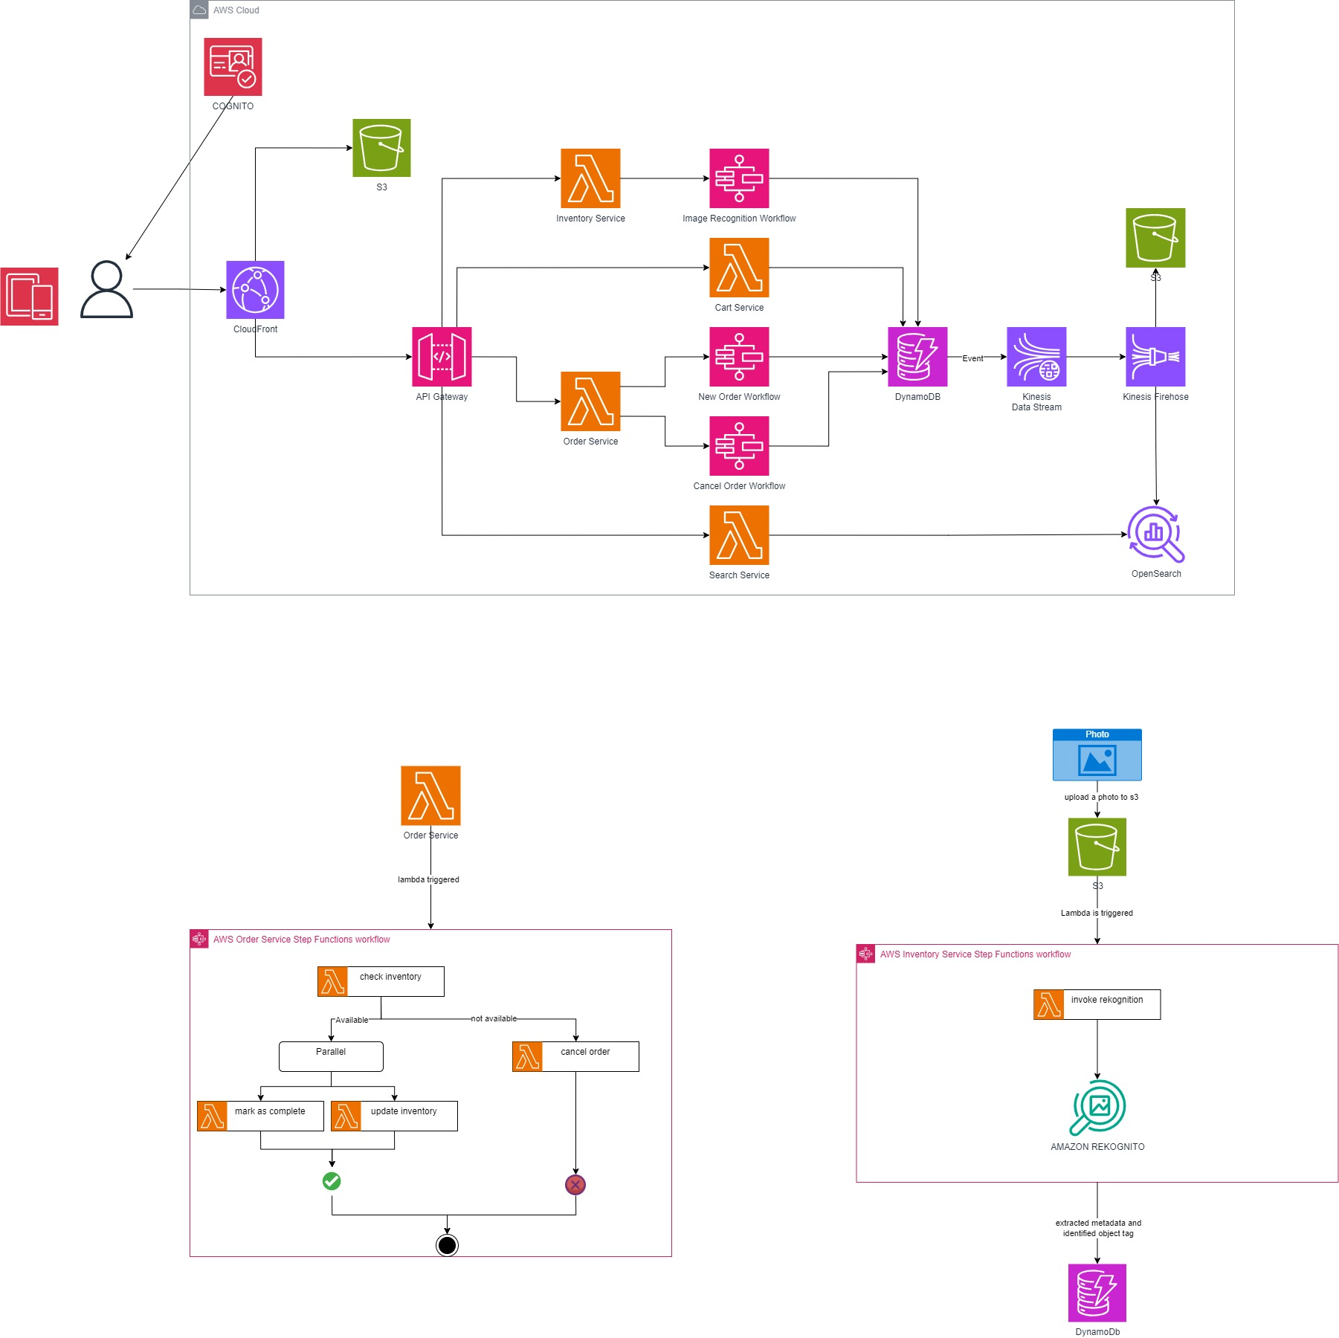

# Expected Contribution

We've outlined how each team member will contribute to our project, considering our individual strengths and areas of expertise:

## Front-End Flutter Mobile Application Development:

Cem will be responsible for developing 100% of the front-end Flutter mobile application. This includes creating the look and feel of the app to ensure a smooth and easy shopping experience.

## Report Writing:

Metehan will handle most of the report writing, covering 90% of this task. Cem will contribute 10% to the report writing. We'll keep communication open throughout to make sure the report is well-rounded.

## Cloud Computing Tasks:

To make sure the workload is balanced, we're dividing cloud computing tasks into 60% and 40%. Metehan will take on 60%, and Cem will manage the remaining 40%. Both of us will work closely on all cloud computing tasks to understand and implement them effectively.

We understand the importance of staying in touch and working together closely. This plan is designed to make the most of each team member's skills, ensuring our platform on the AWS cloud comes together successfully.

# References

[AWS Lambda vs. EC2: Which is Right for Your Use Case?](https://www.linkedin.com/pulse/aws-lambda-vs-ec2-which-right-your-use-case-mr-a-banerjee/)  
[AWS Lambda Pricing](https://aws.amazon.com/tr/lambda/pricing/#:~:text=AWS%20Lambda%20%C3%BCcretsiz,yan%C4%B1t%20ak%C4%B1%C5%9F%C4%B1%20i%C3%A7erir.)  
[AWS Step Function Pricing](https://aws.amazon.com/tr/step-functions/pricing/#:~:text=%C3%9Ccretsiz%20Kullan%C4%B1m,s%C3%BCresiz%20olarak%20yararlanabilir.)  
[Amazon Cognito Pricing](https://aws.amazon.com/tr/cognito/pricing/#:~:text=%C3%9Ccretsiz%20Kullan%C4%B1m,s%C3%BCresiz%20olarak%20yararlanabilir.)  
[Amazon CloudFront Pricing](https://aws.amazon.com/tr/cloudfront/pricing/#:~:text=Her%20Zaman%20%C3%9Ccretsiz,t%C3%BCm%20%C3%B6zellikler%20kullan%C4%B1labilir)  
[Amazon S3 Pricing](https://aws.amazon.com/tr/s3/pricing/#:~:text=AWS%20%C3%9Ccretsiz%20Kullan%C4%B1m,hakk%C4%B1na%20sahip%20olur.)  
[Amazon API Gateway Pricing](https://aws.amazon.com/tr/api-gateway/pricing/#:~:text=Fiyatland%C4%B1rma%20Kaynaklar%C4%B1-,%C3%9Ccretsiz%20Kullan%C4%B1m,Bu%20ayl%C4%B1k%20%C3%A7a%C4%9Fr%C4%B1%20s%C4%B1n%C4%B1r%C4%B1n%C4%B1%20a%C5%9Farsan%C4%B1z%20API%20Gateway%20kullan%C4%B1m%20%C3%BCcretleri%20tahsil%20edilir.,-1%20M%20REST)  
[Amazon SWF (Simple Work Flow) Pricing](https://aws.amazon.com/tr/swf/pricing/#:~:text=%C3%9Ccretsiz%20Kullan%C4%B1m%20*,d%C3%B6nemi%20ifade%20eder.)  
[Amazon DynamoDB Pricing](https://aws.amazon.com/tr/dynamodb/pricing/#:~:text=DynamoDB%20%C3%BCcretsiz%20kullan%C4%B1m,i%C5%9Flemeye%20yetecek%20b%C3%BCy%C3%BCkl%C3%BCktedir.)

Stage 2: Progress Report

# Milestones Achieved:

|  |  |  |  |
| --- | --- | --- | --- |
| Milestone Name | Description | Week | Member |
| Proposal | Proposal for this project is prepared to be submitted. | W7 | All |
| Self-Study | Each group members get ready for the continuation of the project by doing self-study on the AWS topics. | W9 | All |
| API Gateway | Triggers for the Lambda Functions and S3 bucket are created. | W10 | Metehan |
| Lambda Functions | “items” and “inventory” Lambda Functions are implemented using API Gateway endpoints. More specifically search, add, and delete functionalities are implemented. | W10 | Cem |
| DynamoDB | Simple item_table is created to be used by Lambda Functions to store data to DynamoDB. | W10 | Cem |
| GitHub Commits | GitHub commits are done by a group member even though codes are written by either of the group member. | W10 | All |
| Progress Report | Stage 2 of the capstone project. | W11 | All |

Figure: DynamoDB

Figure: Lambda Functions

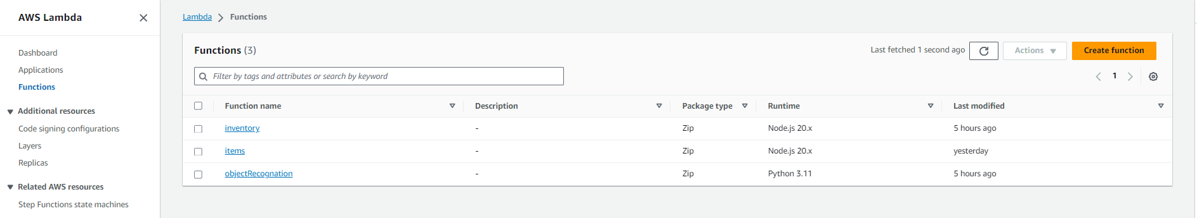

<https://github.com/metumetehan/e-commerce-CNG-495.git>

# Milestones Remained:

|  |  |  |  |
| --- | --- | --- | --- |
| Milestone Name | Description | Week | Member |
| UI | The front-end of the project has not been completely implemented. Therefore, it is not included in this report. | W11 | Cem |
| Image Recognition | Implementing Amazon Rekognito. | W11 | Metehan |
| Integration of UI | Amazon Rekognito and UI integration. Add functionality to suggest and autofill information while adding an item. Uploading an image triggers Rekognito and object recognition information is retrieved to the UI. | W12 | All |

# List of Futures to be delivered:

* Server code.
* Database backup.
* <https://github.com/metumetehan/e-commerce-CNG-495.git>

Stage 3:

# E-commerce Application with ML Capabilities

This project aims to create an e-commerce application where users can conveniently list their products by adding new items. AWS Cognito manages the authentications of each user and customer. Customers can search and add products to their cart. Payment microservice is not included in this project.

This application solves the problem which is faced during listing. It can be listed wrongly categorized due to human error. Our application eliminates this problem by automatically choosing the category for the product based on its image.

To achieve this, the application utilizes image recognition technology from Amazon Rekognition. When users upload an image to add a new item, Amazon Rekognition automatically identifies the object and selects the category for the product. This functionality streamlines the process of filling in item details by automatically populating certain fields based on previously configured specifications of the identified object.

Trendyol is an e-commerce application that is like our application. Main differences are we use image recognition for deciding a category automatically while Trendyol has more capabilities such as payment.

GitHub repository for the back end: <https://github.com/ChesterMETU/e_commerce_CNG495.git>

GitHub repository for the front-end UI: <https://github.com/ChesterMETU/e_commerce_CNG495_ui.git>

And you can find the old repository here: <https://github.com/metumetehan/e-commerce-CNG-495.git>

# Authentication

For authentication, we use AWS Amplify with AWS Cognito. Using Amplify Studio in AWS Console, first we created an Amplify application. Then, to setup authentication, we created a login mechanism and configured it to be logged in using email and password. and we created a sign-up mechanism and configured it to be registered using username, email and password. Then, for the front-end mobile application, we use three Flutter modules: amplify_flutter, amplify_auth_cognito, and amplify_authenticator. Using AWS command line interface, Amplify configurations are pulled using “amplify pull” command. Amplify Authenticator module is used for the UI of login and register.

# Managing Items

## Adding An Item

To add an item, we created a lambda function that is triggered by making a *PUT* request to the following API endpoint: <https://4151wpvtqb.execute-api.eu-central-1.amazonaws.com/items>

In the request body, *name, price, piece, creater_id, product_description,* and *file* must be included. Here is an example body of a request:

    "name": nameController.value.text,

    "price": int.parse(priceController.value.text),

    "piece": int.parse(pieceController.value.text),

    "creator_id": user_id,

    "product_description": descriptionController.text,

    "file": base64img

After the Lambda function is triggered, first we create a new item to the DynamoDB table called *item_table* with the attributes in the request body without image *file* and its category is initially set to unknown. After that, item image provided in the request body as base64 encoded image is decoded and put to S3 Bucket called *rekonimage* by setting key to the *item_id*. You can see the associated function below.

case "PUT /items":

        let requestJSON = JSON.parse(event.body);

        var IDcounter =  await dynamo.send(

          new GetCommand({

            TableName: counterTable,

            Key: {

              counter: "1",

            },

          })

        );

        IDcounter = IDcounter.Item.counterID;

        await dynamo.send(

          new UpdateCommand({

            TableName: counterTable,

            Key: {

              counter: "1"

            },

            UpdateExpression: 'set #c = :x',

            ExpressionAttributeNames: {'#c' : 'counterID'},

            ExpressionAttributeValues: {

              ':x' : IDcounter + 1,

            }

          })

        );

        await dynamo.send(

          new PutCommand({

            TableName: tableName,

            Item: {

              item_ID: `${IDcounter}`,

              price: requestJSON.price,

              piece: requestJSON.piece,

              name: requestJSON.name,

              creator_id: requestJSON.creator_id,

              image: requestJSON.file,

              description: requestJSON.product_description,

              category: "unknown"

            },

          })

        );

        const base64Image = requestJSON.file;

        const decodedImage = Buffer.from(base64Image,"base64");

        const command = new PutObjectCommand({

          Bucket: "rekonimage",

          Key: `${IDcounter}`,

          Body: decodedImage,

          ContentType: "image/jpeg"

        });

        const response = await S3.send(command);

        body = requestJSON.file;

        break;

## Getting All Items

To get all items from the database, we created a lambda function that is triggered by making a *GET* request to the following API endpoint: <https://4151wpvtqb.execute-api.eu-central-1.amazonaws.com/items>

After the Lambda function is triggered, first we send a dynamo scan command to the DynamoDB table called *item_table* with only the table name that is *item_table*. And it returns the list of all the items in the database. Then, it is put in the response body and sent to the client. You can see the associated function below.

case "GET /items":

        body = await dynamo.send(

          new ScanCommand({ TableName: tableName })

        );

        body = body.Items;

        break;

## Getting An Item by ID

To get an item from the database, we created a lambda function that is triggered by making a *GET* request to the following API endpoint: [https://4151wpvtqb.execute-api.eu-central-1.amazonaws.com/items/{id}](https://4151wpvtqb.execute-api.eu-central-1.amazonaws.com/items/%7bid%7d)

Item id must be placed as a path parameter. Here is an example:

<https://4151wpvtqb.execute-api.eu-central-1.amazonaws.com/items/5>

After the Lambda function is triggered, first we send a dynamo *scan* command to the DynamoDB table called *item_table* with the table name and key parameter which is the primary key of the *item_table* and it is taken from path parameter in the request URL. And it returns the list of all the items in the database. Then, it is put in the response body and sent to the client. You can see the associated function below.

case "GET /items/{id}":

        body = await dynamo.send(

          new GetCommand({

            TableName: tableName,

            Key: {

              item_ID: event.pathParameters.id,

            },

          })

        );

        body = body.Item;

        break;

## Deleting An Item by ID

To delete an item from the database, we created a lambda function that is triggered by making a *DELETE* request to the following API endpoint: [https://4151wpvtqb.execute-api.eu-central-1.amazonaws.com/items/{id}](https://4151wpvtqb.execute-api.eu-central-1.amazonaws.com/items/%7bid%7d)

Item id must be placed as a path parameter. Here is an example:

<https://4151wpvtqb.execute-api.eu-central-1.amazonaws.com/items/5>

After the Lambda function is triggered, first we send a dynamo *delete* command to the DynamoDB table called *item_table* with the table name and key parameter which is the primary key of the *item_table* and it is taken from path parameter in the request URL. And it returns the list of all the items in the database. Then, it is put in the response body and sent to the client. You can see the associated function below.

case "DELETE /items/{id}":

        await dynamo.send(

          new DeleteCommand({

            TableName: tableName,

            Key: {

              item_ID: event.pathParameters.id,

            },

          })

        );

        body = `Deleted item ${event.pathParameters.id}`;

        break;

## Getting Item Categories

To get all the item categories from the database, we created a lambda function that is triggered by making a *GET* request to the following API endpoint: <https://4151wpvtqb.execute-api.eu-central-1.amazonaws.com/itemcategorys>

After the Lambda function is triggered, first we send a dynamo *scan* command to the DynamoDB table called *item_table* with the table name. And it returns the list of all the items in the database. Then, all the item categories in the list are put into a dictionary and distinct categories are send to the client via the response body. Here is the associated function:

case "GET /itemcategorys":

        var items = await dynamo.send(

          new ScanCommand({ TableName: tableName })

        );

        items = items.Items;

        const distinctValues = {};

        items.forEach(item => {

          const attributeValue = item["category"];

          distinctValues[attributeValue] = true;

        });

        body = Object.keys(distinctValues);

        break;

# Image Rekognition

To decide the item category of an item, we created a lambda function that is triggered whenever an item is put into the S3 Bucket called *rekonimage*. First, the function gets bucket name and key of the item from the event header. Using those parameters, the function gets the image from S3 Bucket and then it is sent to AWS Rekognition. AWS Rekognition returns the data that we can get the item category from. Then, the function updates the item category in the database by sending *update* command with the table name which is *item_table* and key which is S3 item key.

bucket = event['Records'][0]['s3']['bucket']['name']

key = urllib.parse.unquote_plus(event['Records'][0]['s3']['object']['key'], encoding='utf-8')

print(bucket,key);

try:

    result = rk.detect_labels(

    Image={'S3Object':{'Bucket':bucket,'Name': key},},

        MaxLabels=1,

        Features=[

    'GENERAL_LABELS',

    ],

        )

    print(result)

    update_response = db.update_item(

        TableName= "item_table",

        Key={"item_ID": {

            "S": key

            }

        },

        ExpressionAttributeNames={

            '#C': 'category',

        },

        ExpressionAttributeValues={

            ':c': {

                "S": result["Labels"][0]["Categories"][0]["Name"],

            },

        },

        UpdateExpression='SET #C = :c',

        ReturnValues="UPDATED_NEW",

    )

    return "Success"

except Exception as e:

    print(e)

    print('Error getting object {} from bucket {}. Make sure they exist and your bucket is in the same region as this function.'.format(key, bucket))

    raise e

# Inventory

To asd, we created a lambda function that is triggered whenever an

|  |  |  |  |
| --- | --- | --- | --- |
| Part | AWS Service | Programming Language | Lambda Function Name |
| Authentication | AWS Cognito & Amplify | Node.js 16.x Node.js 18.x | amplify-login-create-auth-challenge-56c36a45amplify-login-custom-message-56c36a45amplify-ecommerceflutter--UpdateRolesWithIDPFuncti-TeqqfJtbBnasamplify-login-verify-auth-challenge-56c36a45amplify-login-define-auth-challenge-56c36a45 |
| Managing Items | DynamoDB & S3 Bucket | Node.js 20.x | items |
| Image Recognition | AWS Rekognito & S3 Bucket | Python 3.12 | rekonObject |
|  |  |  |  |